**Contents**

6. Financing the green transition 1

6.1 Mobilising private finance 2

*Financing instruments* 3

*Private sector’s sustainability disclosures* 7

6.2 Fostering sustainable investments through the next MFF 12

6. Financing the green transition

**Achieving the ambitious EU climate and environmental objectives requires a substantial increase in sustainable investments in the EU.**

Since 2020, the European Commission has published multiple estimates on different investment needs for achieving specific strategies (e.g. RePowerEU, 2040 climate target). While recognising the existence of several EU-based reports assessing the investment needs and gaps (e.g. I4CE, Rousseau Institute), this section reports on EC’s official estimates for public and private investment needs and gaps required to achieve the EU’s climate and environmental objectives (referred hereafter as ‘sustainable investments’). These estimates can vary considerably due to changes in the macroeconomic context (e.g. energy crisis, inflation) and technology costs, but also due to different definitions, scope, methodologies and timelines for assessment. Nonetheless, these offer an indication of challenge faced by the EU, as well as the need to substantially increase the volume of sustainable investments.

Under the Fit-for-55 package, the annual investment gap for **climate change mitigation** - to achieve a greenhouse gas emission reduction of at least 55% by 2030 - was estimated to be EUR 477 billion (between 2021 and 2030)[1]. Since then, this investment gap has further increased to **over EUR 620 billion** annually, due to additional investment needs for RePowerEU and the Net Zero Industrial Act, which requires EUR 35 billion per year (2022-2027)[2].

Estimates for investment needs and gaps for **climate change adaptation** are less clear-cut, considering the uncertainties in climate change projections, as the alignment of adaptation investment needs is strongly dependent on model assumptions and scenarios. This uncertainty is further reinforced by a lack of data to assess physical risk and adaption needs (see Chapter 3). Hence, existing estimates range between EUR 30 and EUR 500 billion annually in Europe based on different scenarios.[3]

**Environmental objectives**, namely pollution prevention & control, circular economy and waste, water protection and industries, and biodiversity and ecosystems, will require a total investment need of EUR 341 billion per year between 2021 and 2027 (corresponding to 2.2% of EU GDP) [4]. This means that a EUR 114 billion annual investment gap exists, where pollution prevention and control and circular economy and waste have the biggest annual investment gaps at EUR 40.7 billion and EUR 26.6 billion, respectively.

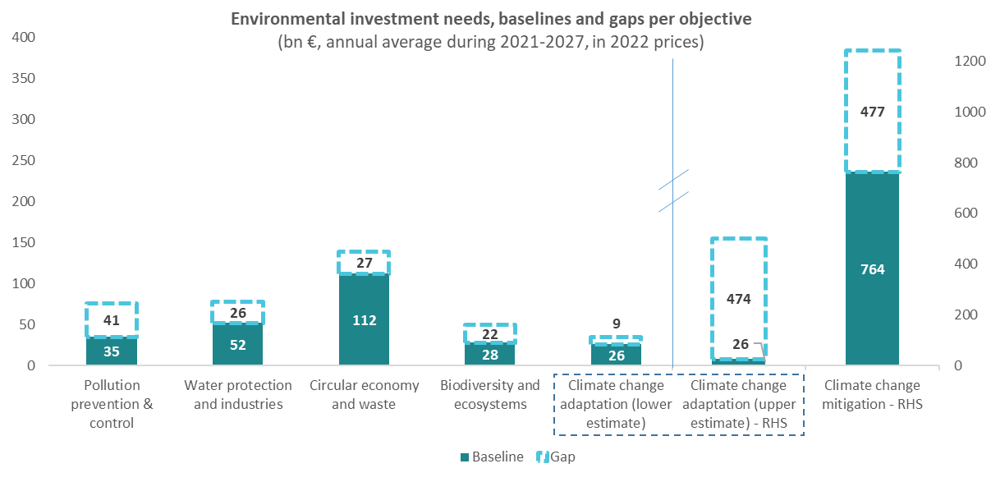

**FIGURE X** – Investment needs and gaps per climate and environmental objectives. Adapted by JRC, based on DG ENV data + … NB: Climate change adaptation Baseline figure refers to total EU funding for Disaster Risk Management and climate change adaptation under Cohesion policy funds, the European Agricultural Fund for Rural Development, the Recovery and Resilience Facility[5]. RHS - …

**Despite this, significant amounts of public and private investments still flow towards harmful activities.**

Between 2015 and 2021, fossil fuel subsidies in the EU remained relatively stable at approximately EUR 56 billion (2022 prices) per year. However, due to the energy crisis in 2022, fossil fuel subsidies increased to EUR 123 billion in 2022, exceeding the amount of subsidies for renewable energy in the same year (EUR 87 billion in 2022)[6]. Fossil fuel subsidies represent only a fraction of subsidies that are harmful to the environment (also known, as environmentally harmful subsidies). As part of the 8th Environmental Action Programme (EAP) and to fulfil international commitments[7], the EC is currently developing a methodology to define and identify environmentally harmful subsidies[8]. Therefore, there is no official estimative of the total amount of public funds in the EU currently harming the environment.

Fossil fuel finance has been steadily reducing in the most recent years from more than EUR 800 billion in 2018 to less than 600 billion in 2023. For the EU, the trajectory of fossil fuel finance exhibits a more cyclical behaviour, but since a peak annual volume of above EUR 110 billion in 2014 has overall retreated to lower amounts, with approximately EUR 60 billion in 2023.

**Addressing investment needs will require substantial contributions from private finance; and public funding can play a strategic shaping role.**

Considering the size of the investment gap, private financing will be key to reach the objectives of the EU Green Deal, particularly in the current context of constrained public funding. In fact, the public share of investments is estimated to range from 25%[9] to 50%[10]. EU public funding can play a strategic shaping role by focusing on its leveraging and signalling functions. Through well-designed instruments, EU funding can leverage/mobilise private financing, whilst funding decisions can send signals to the market about the kind of investments the EU is prioritising, as well as deprioritising, to achieve the green transition.

This section tackles two crucial issues in financing the EU green transition, namely mobilising private finance and fostering sustainable investments through the next MFF. The aim is not to provide an exhaustive view of potential challenges and opportunities for action, but to highlight critical factors that policymakers can have in consideration when designing and implementing policies related to sustainable investments.

* 1. Mobilising private finance

As per the Commission Recommendation (EU) 2023/1425[11], sustainable finance includes what is referred to as ‘green finance’ that is already environmentally-friendly and ‘transition finance’ that is transitioning towards those environmental performance levels over time, including when the activity or company being financed is environmentally-harmful as of today but presents credible ambition and ability to transition. What falls within these categories will evolve in the short, medium and long term as the levels of stringency evolve during the transition to a sustainable economy.

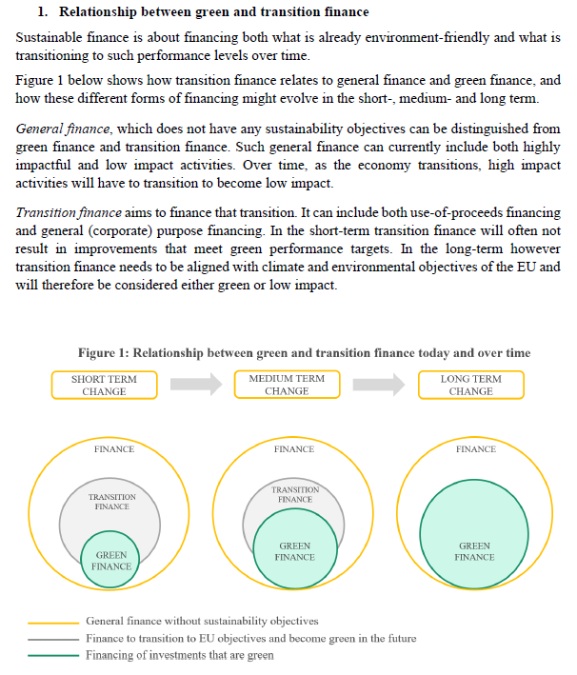

Figure **X** - Relationship between green and transition finance today and over time, as included in the Commission Recommendation (EU) 2023/1425 on facilitating finance for the transition to a sustainable economy

The EU Sustainable Finance Framework aims to provide a basis for the development of green and transition finance. Certain bottlenecks to accessing green and transition finance can be overcome via financial instruments such as green bonds, sustainability-linked bonds, and venture capital. The opportunities created by existing and possible future EU regulations relating to these financial instruments are explored in the section 1.1.

Developing the EU Sustainable Finance Framework and supporting green and transition finance instruments depends on the availability and quality of sustainability disclosures. These disclosures create an opportunity to monitor the flows of green and transition finance, to harmonise impact reporting and to enhance the verification of sustainability claims that are explored in section 1.2. A new and strategically important source of disclosures for transition finance are transition plans. Therefore, section 1.2 deep-dives the opportunities that the European Commission has to support transition plan preparers, user and supervisors as well as regulators. It also explores how transition plans create opportunities for increasing access to finance via financial instruments and via informing public policy planning.

*Financing instruments*

**Key message #1: Bottlenecks in the access to finance to be addressed by leveraging on standardised green instruments and venture capital**

According to the IPCC (2023) report[12], “*there is sufficient global capital to close the global investment gaps but there are barriers to redirect capital to climate action*”. Bottlenecks to access finance are reported as one of main drivers of the lack of private green investment. According to the 2021 EIBS survey[13], 59% of European firms point to the availability of finance as an obstacle to climate investments. This share varies across regions, with Southern Europe hosting the highest fraction of firms reporting unavailability of finance as a major obstacle to green investments (45% of surveyed enterprises). European firms need to attract green-minded investors and diversify their sources of funding reducing their reliance on bank credit amid the fragmented and undersupplied capital markets. To do so, several financial instruments still under-used could be leveraged.

**Opportunity 1.1: Leverage EU Green Bond Standard to develop market finance for green investments**

Debt capital markets are playing an increasingly important role in scaling up private funding for green investments, also thanks to the development of specific financial instruments. Green bonds are debt securities issued to finance investment projects with environmental and climate benefits. To date, green bond proceeds are predominantly used to finance projects for energy efficiency, clean transportation, and green buildings[14],[15]. Since its inception in 2007, the green bond market has grown steadfastly. Figure 1 plots total annual bond issuances in the EU, broken down by issuer type, and as a percentage of the total bond market. The share of green bonds in the EU27 was below 1% in 2013, but has significantly increased since then, and even more markedly from 2016, on the back of strong market demand leading to favourable pricing conditions[16]. In 2022, green securities accounted for 16% of newly issued bonds in the EU27, and only 2% of overall issuance by non-EU entities.

The European Green Bond Standard (EuGBS) provides the first regulatory standard for “European Green Bonds” applying from 21 December 2024. Building on market best practice, the EuGBS relies on the criteria of the EU taxonomy to define green economic activities and issuers must explain how the proceeds contribute to funding their transition plan as per the Corporate Sustainability Reporting Directive (CSRD) if they are subject to the CSRD or have voluntarily published a transition plan The standard has clear reporting requirements and foresees a system of supervision of companies carrying out pre- and post-issuance reviews at European level. The EuGBS will significantly increase transparency and certainty, thus further promoting the development of the EU green bond market. Moreover, green bond issuance by sovereign entities and governments can in fact stimulate corporate issuances, by providing benchmarks for market practice and disclosure[17]. With ad hoc provisions on securitisation, the EuGBS could be leveraged also for the securitisation market in Europe, as advocated in the Draghi report,[18] even if currently the interest is still limited. Overall, in line with what the Letta report advocates[19], the market for green and sustainable debt has the potential to act as a catalyst for the development of the whole EU financial market.

Figure **X** -Green bond issuance in the EU, by year and issuer type

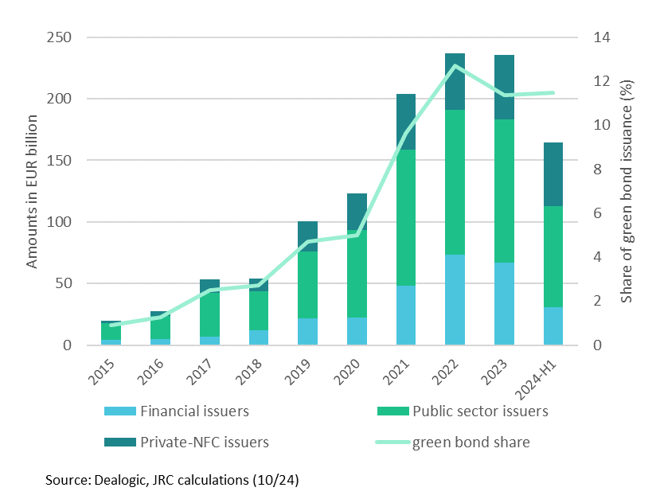

**Opportunity 1.2: Reinforcing the credibility of sustainability-linked bonds as transition and green finance instruments**

Unlike green bonds, whose proceeds are tied to specific ‘green’ projects, sustainability-linked bonds (SLBs) raise finance for the pursuit of entity-level sustainability-related targets. In practice, the financial conditions of the SLBs are explicitly linked to the overall sustainability performance of the issuer. While there are open questions on the incentives embedded in the specific security design, SLBs are a recent innovation that has gained much attention for their use as a transition finance instrument. At EUR 54.5 billion, the volumes of SLBs issuance peaked in 2021 (Figure 3), declining afterwards potentially because of the increased attention and scrutiny from investors on the design of this instrument. Concerns are mainly on the structure of incentives embedded in a system that, by increasing due payments, financially penalises the issuer failing to reach the declared sustainability targets. This would reduce ambition in the declared targets to avoid the increase in the cost of debt[20]. To prevent this from happening and further develop trust in this market, there is potential for additional guidelines and standards to grant the necessary conditions – including the alignment of incentives for issuers and investors alike and balancing financial and environmental needs. An example in this direction is the 2024 update of ICMA’s Sustainability-Linked Bond Principles (SLBP), which heads to lining up the choice of the KPIs to track with the issuer’s sustainability strategy.

Figure **X** - Sustainability-linked bond issuance in the EU

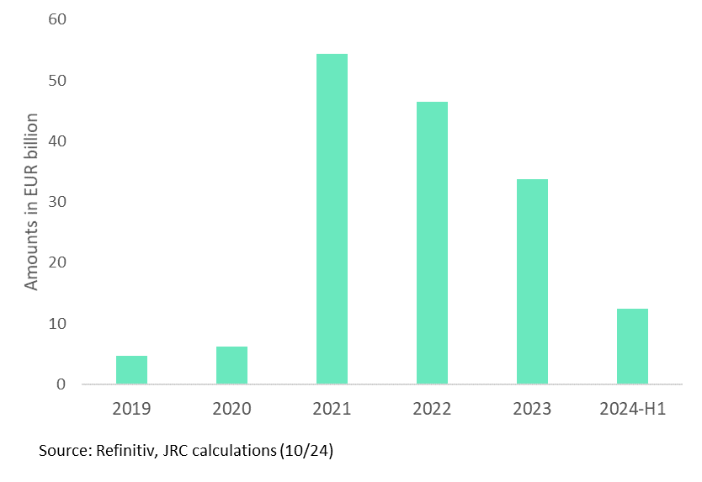

**Opportunity 1.3: Exploit the untapped potential of venture capital to finance green innovation**

Private equity financiers and venture capitalists are particularly well-equipped to finance innovative companies, and they may play an important role in the funding of low-carbon technologies[21]. At EUR 4 billion in 2023, investment in clean tech industries accounted for roughly 5.7% of the total private equity market in the EU. The growth in 2023 was driven by an increase in buyout capital, meaning investments in already established companies, while in the first half of 2024 venture capital, i.e. investment in new companies, represented the highest share of the total, at EUR 800 million. In the first half of 2024, growth and venture capital have already reached the 2023 end-of-year level, forecasting a strong development on those markets in 2024. Nonetheless, overall, the level of the private equity investment in clean tech industries remains low, suggesting an untapped potential of venture capital to fund green innovation[22], [23]. Fostering market integration and reducing barriers to cross-border asset allocation can help mobilise private savings, and redirect them towards equity investments in innovative firms. Moreover, liquid and less fragmented capital markets are also essential to favour the growth of innovative start-ups.

**Figure X** Privateequity in CleanTech industries

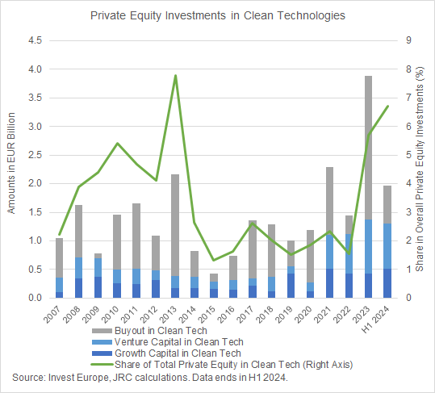

*Private sector’s sustainability disclosures*

**Key Message #2: Making the most of the EU sustainable finance regulatory framework and capitalising on increasing data availability**

The EU regulatory framework on sustainable finance aims to steer the reallocation of capital and enable private investments towards green and transition technologies and business models. As the ultimate goal is greening the real economy, assessing the extent to which financing is redirected towards sustainable and transition investments is of paramount importance from a policy perspective. In this area, however, substantial data gaps remain, which hinder a comprehensive tracking of investment in the real economy and the underlying sources of finance.[24]

Furthermore, although the EU has established several regulatory frameworks to support data availability for sustainable finance, there are some inconsistencies between them. These can create confusion and increase reporting burdens. For example, the SFDR does not directly use the criteria of the EU taxonomy, creating potential gaps in sustainability assessment. Current disclosure requirements vary across instruments: green bonds follow strict project-based reporting, while sustainability-related instruments have more flexible criteria. For instance, the recent evolution of the SLB market might point to a possible need to include them in the EU sustainability structure. Indeed, the Commission is due to publish a report on potential steps forward for sustainability-linked bonds in the context of the EuGBS regulation. This fragmentation makes it difficult for investors to compare sustainable investments and increases the risk of greenwashing. The 2024 Final Report on Environmental Claims in the EU found that more than 50 percent of environmental claims are vague or misleading, highlighting the urgent need for standardisation[25].

**Opportunity 2.1: Mapping financial and investment flows**

As discussed in a JRC methodological report[26], the disclosure requirements for financial and non-financial actors envisaged in the EU sustainable finance legislation are expected to significantly increase transparency and availability of sustainability-related information. A regular monitoring and mapping of financing and investment trends for different instruments and sectors following the key principles as sketched by the JRC and the EU Platform on Sustainable Finance[27] should allow to track progress across time, in both green and brown sectors, and design targeted policies for specific market segments and for those sectors staying behind.

**Opportunity 2.2: Harmonise impact reporting standards for sustainable finance instruments**

Harmonising impact reporting standards would create a single, consistent framework that applies uniform criteria to all sustainable finance instruments. This alignment would simplify compliance, particularly for SMEs, while ensuring that sustainability claims are judged against consistent standards. Standardising reporting formats and frequencies would improve transparency and facilitate more effective market oversight. The future standard for the voluntary reporting of sustainability disclosures by SMEs (“VSME”), which do not fall in the scope of mandatory reporting under the CSRD, may play a role in this regard, particularly if supplemented by a taxonomy-related module.

**Opportunity 2.3: Enhance verification of sustainability claims of sustainable finance instruments through standardised sector-specific impact metrics.**

Effective verification of sustainability claims need not increase administrative burden. By establishing clear sector-specific metrics based on the ICMA Handbook approach, the EU can actually simplify reporting requirements while enhancing credibility.[28] This standardisation would replace the current fragmented reporting requirements with a single, streamlined framework. Following the principle of ex-post reporting of the EuGBS, a harmonised verification system would focus on material impacts rather than extensive documentation, making compliance easier and less costly. For sustainability-related instruments, standardised performance indicators would eliminate the need for customised frameworks, reducing complexity especially for SMEs. This approach moves away from bureaucratic box-ticking towards meaningful impact assessment, reducing duplicate reporting requirements across different regulations. Key to this simplification is the "report once, use many" principle, where standardised data serves multiple regulatory purposes. By extending the EU Taxonomy's coverage to all sectors through clear, practical criteria, companies would benefit from greater certainty and reduced compliance costs, while ensuring robust environmental integrity.

***Box xxx: Enhancing the implementation of the EU Taxonomy***

The European Commission is doing extensive work to improve the usability and facilitate the implementation of the EU Taxonomy (e.g. through the development of the Taxonomy Compass and the publication of multiple FAQs). In this context, providing economic operators with additional, tailored tools to disclose their eligibility and alignment information could strengthen these efforts and contribute to reduce the administrative burden. These customised disclosure tools could include for instance:

1. Crafting comprehensive guidance tools, which provides explicit information on the required documentary evidence to prove compliance with each technical screening criteria, particularly for the most challenging Do No Significant Harm (DNSH) criteria to implement.

2. Creation of dedicated web portals for sustainability data reporting. These portals would streamline reporting, reduce reliance on private providers and thus reduce costs, enhance data security and confidentiality, improve data quality and consistency, and foster transparency and accountability among companies.

3. Facilitating the implementation of EU Taxonomy for SMEs, since these are affected by data requests trickling down from value chain partners or from clients. SMEs face significant hurdles in their Taxonomy reporting, as setting up robust data collection processes is complex and expensive, and requires considerable technical resources and skills. To address these issues, the Platform on Sustainable Finance has proposed tailored approaches for listed and unlisted SMEs. The European Commission could further consider these proposals to facilitate the Taxonomy's implementation for SMEs, ensuring that SMEs can effectively demonstrate their environmental sustainability and access sustainable finance.

4. Providing upfront clarification on when compliance with EU laws ensures compliance with requirements contained in the DNSH technical screening criteria in the existing delegated acts. This would facilitate the verification of compliance for economic activities implemented in the EU, potentially lowering reporting costs and reducing administrative hurdles for companies operating in the EU.

**Key message #3: Transition Plans, the keystone to target transition finance**

A targeted use of transition finance is required to align all sectors with the ambitions of the EU Green Deal and ensure a competitive EU economy, avoiding lock-in to high-impact stranded assets. This is particularly important for those sectors that have a high environmental and climate impact. Transition plans that set out precise transition strategies are garnering increasing attention across jurisdictions[29] and have the potential to act as the central connection point informing targeted transition financing decisions. These plans define performance and impact indicators which can then be used to issue green and sustainability loans and bonds for green and transition purposes (e.g. use-of-proceeds or general-purpose instruments such as green and sustainability bonds or sustainability-linked bonds). In 2024, 37% of polled investors in a Robeco study[30] said they already invest in companies with high emissions if they have credible transition plans, and an extra 26% are planning to do so in next 1-2 years.

The Corporate Sustainability Reporting Directive’s (CSRD) European Sustainability Reporting Standards (ESRS)[31] contain detailed disclosure requirements for companies that develop a transition plan for climate change mitigation (ESRS E1-1) and the Corporate Sustainability Due Diligence Directive (CSDDD) goes further for a subset of firms by making mandatory the transition plan development and implementation through best efforts. When material for the entity, transition plans may also be connected to actions and resources for other environmental objectives (ESRS E2 to E5) as well as a just transition aspects, for the entity’s own workers, but also for workers in the supply chain, affected communities and consumers (ESRS S1 to S4). Thanks to the definition of transition plans in the CSRD investors have a common reference for what to look for in a company’s transition plan, therefore facilitating transition financing.

To serve investors with valuable information to address climate-related and environmental risks and to inform their progress towards their own sustainability targets[32], transition plans need to be credible. Credible corporate transition plans can also inform investors’ identification of investment opportunities and serve as a basis for engagement with their investees. This is reflected in the ECB’s 2022 ‘Good practices for climate-related and environmental risk management’[33]. Companies’ transition plans are therefore essential to inform investors’ own prudential transition plans[34]. Prudential transition plans are included as a requirement for credit institutions in the Capital Requirements Directive (CRD VI) and are detailed in the EBA ‘Guidelines on the management of ESGrisks’[35]. Similarly, insurers must develop and monitor the implementation of plans to address risks arising from sustainability factors as per the Solvency II Directive and EOIPA’s report on ‘Prudential treatment of sustainability risks’[36].

**Transition plan preparers** face a challenge to develop a holistic strategy, potentially affecting the core business model of the company and including with implications for different departments. ESRS E1-1 provides a regulatory basis for companies to develop their transition plan, and to provide transition plans’ users with the key disclosures at an appropriate level of granularity. Additional considerations may be required when developing prudential transition plans.

**Opportunity 3.1:** **Providing guidance, capacity building and tools to support the development of transition plans that deliver actionable insights.**

The European Commission has an opportunity to aid companies along this journey by providing guidance on ESRS E1-1 and other related transition plan requirements, building on EFRAG’s early draft on implementation guidance for climate mitigation.[37] Subsequent capacity building programmes and toolkit development will be needed, including reference points on European Climate Law aligned paths at sectoral level. This would respond to a growing market demand for EU sectoral pathways from transition plan preparers[38], allowing them to plan their transition, a necessary condition for the EU to achieve its own policy targets. Good reporting practices in line with guidance on ESRS E1-1 could also provide a reference of transition plans for identifying transition finance needs as well as transition finance flows.

***Box ** - Towards a transition finance data hub ?***

Companies are facing difficulties in finding appropriate and reliable databases and calculations tools to produce their CSRD reports. However substantial set of materials already exist at EU or MS level. A data hub might be created to enhance visibility of these material and therefore support the implementation of the CSRD. This free of charge centralised access point might include, for example:

1. References of emission factors databases to support the calculation of companies’ GHG emissions - scope 1, 2 and 3 - (see example in France[39], the Netherlands[40], among others).
2. An online simplified GHG emission calculator tool specifically designed for SMEs (see example from the US Environmental Protection Agency[41]).
3. Science-based sectoral pathways and scenarios -in line with NECPs and EU climate objectives- to support the design and credibility assessment of Climate Transition Plans.
4. Example of good practices and initiatives to implement concrete GHG emission reduction from companies.

**Transition plan users** will need to analyse transition plans as part of their ESG risk management processes and engage with investees accordingly. In light of this, investors have started to develop frameworks for assessing the credibility of company transition plans[42] but often ask for further guidance on key points such as the alignment of transition plans with EU or national policies and how to demonstrate compatibility with 1.5°C aligned paths at sectoral level. When asked if they lack clarity on how to assess the credibility of transition plans by using decarbonisation pathways, 62% of financial market participants polled in 2022 OECD study[43], answered ‘Yes’ or ‘Somewhat, depending on the region’. There is also a growing market demand for guidance from transition plan users on pathways[44],[45],[46] and a growing risk of conflicting approaches and of delay to transition finance due to uncertainty in the market if no common definition of a credible transition plan is developed.

**Opportunity 3.2: Providing an assessment framework for transition plan credibility that brings clarity and consistency, unblocking transition financing.**

The European Commission has an opportunity to provide a basis for these credibility assessments by developing an EU Transition Plan Credibility Assessment Framework (EU TP-CAF). This could be supported by methodologies for transition plan users to assess transition plans in light of the aforementioned technical reference points on European Climate Law aligned paths at sectoral level. An EU TP-CAF would provide clarity for the market by building on the definition of transition finance as per Commission Recommendation (EU) 2023/1425[47] and help to unblock transition financing, including via blended finance. This could also help to define a transition finance category for the revision of the Sustainable Finance Disclosure Regulation.

**Transition plan assurers and supervisors** will need to develop a breadth and depth knowledge beyond the usual areas of work for assurance and supervisory bodies that will be required to fulfil these duties. New skills will be required to assess the design and adoption of company transition plans and the progress in addressing climate-related and environmental risks in prudential transition plans.

**Opportunity 3.3: Upskilling the supporting ecosystem so that transition plan related duties can be fulfilled.**

The European Commission has an opportunity to support the necessary upskilling through mechanisms such as Technical Support Instruments.

**Financial instruments that connect to transition plans** can foster access to transition finance in hard-to-abate sectors, however, the current sustainable finance framework has a strong focus on project-based instruments, with green bonds accounting for 47% of sustainable finance instruments in 2022[48]. Financial instruments that connect to a company transition plan would help investors understand how specific green projects fit into a company's overall sustainability strategy, reducing the risk of isolated "green pockets" within otherwise carbon-intensive operations. Potentially, SLBs may serve as a tool to directly link the achievement of sustainability targets (as stated in a company’s transition plan) to the necessary financial resources to reach them.

**Opportunity 3.4: Transition plans as a basis on which to build financing instruments, and to monitor the transition.**

The European Commission has an opportunity to promote and monitor the use of sustainable instruments that connect to transition plans. Already existing sustainable securities can be fit for transition financing if they connect to the outcomes of a transition plan. Use-of-proceeds instruments should detail how the specific proceed contribute to the overall transition objectives, while sustainability-linked instruments should be framed around the KPIs at the core of the company’s transition plan. This approach would be particularly beneficial for sustainability-linked bonds and loans whose targets are set at the entity level. By monitoring the real-economy transition at company level, regulators can better assess whether sustainable finance instruments are truly supporting the transition, rather than simply funding stand-alone green initiatives. To achieve this, it will be key to monitor the issuance of the different sustainable instruments by entities at different stages of transition.

**Informing policymaking using data from companies’ transition plans** is key to ensure a coordinated transition that is built on an informed dialogue between private and public actors**.** Substantial interdependencies exist between public policies and corporate transition plans. As detailed in the JRC Science-for-Policy brief on the topic[49], a company’s transition plan may have a geographical dependency[50] on the availability of infrastructure required to decarbonise (e.g. H2 pipelines). The availability of this infrastructure could be largely influenced by factors such as public finance support. In turn, the capacity of the public sector to achieve its climate ambition will be directly affected by the private sector, and the confidence to adopt more ambitious climate policies will increase in line with the private sector’s commitments. Inconsistent strategies could slow down the implementation of climate actions and increase the risk of not delivering on commitments.

**Opportunity 3.5: Capitalising on transition plans to coordinate policy and private action, ensuring an efficient transition.**

The data reported in transition plans and understanding the dependencies between companies’ transition plans and public policy on climate change, such as NDCs, NECPs and regional policies, presents an opportunity for achieving a coordinated transition. Leveraging the finance needed to transition and increase the competitiveness of the EU economy will require coordination between policymaking and private finance, and a common definition of transition plan credibility. This is also important when considering how the EU budget can support the transition of the real economy. Credible transition plans, containing asset-level information where relevant, may help to identify where opportunities exist (e.g., regional innovation hubs and clusters, expenditure gaps in network infrastructure where private investment can be crowded in) and where companies need most support to avoid the stranding of assets that are not able to transition. Analysing the dependencies between public decarbonisation strategies and the private sector transition plans may provide insights on transition risk (geographical dependencies at EU, Member States or regional scale), on areas to prioritise and potential for collaboration on infrastructure development (e.g., CO2 pipelines), or on how to manage competition for a scarce resource in the transition (e.g., biomass). Such analysis could support informed and iterative dialogues between policymakers and companies as part of designing industrial competitiveness and climate policy.

* 1. Fostering sustainable investments through the next MFF

In the current 2021-2027 Multiannual Financial Framework (MFF), multiple EU funding programmes have integrated climate and, in some cases also environmental, spending targets. This has permitted to mobilise significant amounts of EU expenditure towards the green transition.

Though not sufficient on its own, climate and environmental mainstreaming in the EU budget is still necessary to contribute to mobilise the high volume of investments needed to achieve EU green transition objectives. This needs now to be integrated within the new priorities for the EU budget, which aim to make it **more focused, more impactful and simpler**[51].

Ensuring a more **focused and impactful budget** in the area of ‘green mainstreaming’ is linked to questions on how to maximise the synergies between the green transition and other policy priorities (e.g. competitiveness, social aspects), where EU funds add highest value with respect to private or national funding or what financing strategy (e.g. direct financial support, de-risking private investments) is better suited to address the investment needs under each climate and environmental (sub)objective.

However, defining appropriate answers to these questions is in many cases hindered by the lack of existing data and information on the actual result or impact of the EU budget on climate and environmental objectives, as well as on granular analysis on the scale and nature of the sustainable investment needs (see Key Messages #4).

In this context, this section focuses on the need to improve methodologies that allow to monitor and assess the impact of the EU budget, in order to identify potential answers to these questions and better inform policy decisions (see Key Message #5).

At the same time, **simplifying the budget requires decisions at multiple levels**, from the design of the MFF to the specific investments supported and the requirements that are set. Within this broader context, this section focuses on potential strategies to harmonise and provide upfront clarity on environmental requirements in EU funds. The aim is to foster simplification and increase the predictability of funding decisions without undermining the contribution of the EU budget to achieve EU’s climate and environmental objectives (see Key Message #6).

Finally, the text points out to the increasing importance that national budgets could play in the next MFF to move towards closing of the sustainable investment gap. This is for instance included in the political guidelines for the 2024-2029 Commission, which highlights the important role of public procurement to create lead markets in clean and strategic technologies. As such, the document focuses on the existing opportunity to harmonise and simplify the landscape of ‘green transition tools’ that Member States can apply to identify, monitor and ultimately foster sustainable investments (see Key Message #7).

**Key Message #4. There is no ‘one-size-fits-all’ green and transition finance strategy: closing the investment needs and fostering EU sustainable competitiveness requires targeted strategies for different environmental objectives and policy sectors.**

Climate and environmental objectives coexist with other strategic objectives (e.g. social, industrial, economic security) embedded in the EU budget and in the different EU funds into which these targets are mainstreamed. Whilst in some cases synergies exist, climate/environmental objectives (see Chapter 2) and other strategic objectives can compete or lead to trade-offs between them. In this context, how to foster win-win situations and minimise trade-offs between objectives is a key question that needs to be further explored.

**Opportunity 4.1: Developing more granular analysis at the (sub) objective/sector level to define targeted support strategies for the green transition.**

There is not a clear, single solution on how to maximise the impact of EU funding for the green transition. Each one of the green transition objectives and sub-objectives have specific characteristics, such as the actors involved (MS, local authorities, private investors…), the market failures that need to be addressed, the profitability of the investments or who bears the cost of inaction, among many others.

As an example, decarbonising industry may require establishing targeted instruments to de-risk (e.g., through blended finance) specific investments by the private sector. However, fostering climate resilience through adaptation can require a more prominent role of public support, which may include setting stronger financial incentives for private actors or strengthening climate change adaptation requirements across different funds (see box X below).

In this context, a more granular analysis of the sustainable investment needs and gaps is needed to better inform decisions on the best approaches that maximise the added value of EU money for different climate or environmental (sub) objectives. These analyses could focus on key sectors of high relevance and would require targeted approaches to collect and analyse the information (see for instance Opportunity #3.4 above on the possibility to use the information arising from corporate transition plans to help better identify investment needs from a climate change mitigation perspective for sectors, such as energy-intensive industries).

Furthermore, these analyses can also help to better understand, at sectoral level, the interrelationships between the green transition and other key policy priorities, particularly the fostering of EU sustainable competitiveness, helping to identify options to maximise win-win situations and minimise trade-offs when using EU funds to pursue these priorities.

**Box X - The role of public funding to address investment needs on Climate Change Adaptation**

Adaptation projects display positive externalities in the sense of positive benefits for society as a whole. However, the volume of financial flows towards these projects is significantly lower than those targeting climate change mitigation. *Climate Policy Initiative[52]* estimates that climate mitigation finance reached a yearly average of USD 1.15 trillion (ca. € 1.03 trillion) in 2021/2022, out of the USD 1.27 trillion (ca. € 1.14 trillion) in global climate finance for the same period (Buchner et al., 2023). In comparison, finance to climate change adaptation amounted to only USD 63 billion (ca. € 56.6 billion), one order of magnitude lower than the volume of finance raised by fossil fuel industries worldwide (ca. € 600 billion in 2023).

Furthermore, adaptation finance is characterised by the predominance of public flows, which represent 98% of the total adaptation expenditure in 2021/2022 (Buchner et al., 2023). This can be explained by different factors, such as the fact that the environmental and social benefits provided by adaptation projects are not fully captured in the rates of return for the investment and, hence, generate unfavourable risk-return profiles for investors (Stout 2022).

In this context, greater financial incentives for private actors to invest in adaptation, through tax breaks or benefits, risk guarantees, credit enhancement, grants and concessional loans, can help to compensate for the uncaptured externalities. As stated in the EEA *European Climate Risk Assessment*, Member States could design market incentives to foster private sector investment in climate adaptation, such as specific funding for SMEs or public procurement instruments.

In addition, private investors’ and adaptation projects’ horizons normally do not match (Stout 2022). While private actors operate in the short or medium term, adaptation projects can bring benefits only in the long term, conditional upon uncertain climate outcomes. Furthermore, adaptation investment is context- and location- specific, and so are its benefits.

Long-term planning is also needed to identify and prioritise adaptation needs across sectors in a public- private dialogue.[53] In this spirit, the new EU Strategy on Adaptation to Climate Change advocates for a close cooperation of local authorities between and within Member States in the definition of adaptation strategies and plans.

**Key Message #5: Efforts to make the EU budget more impactful also require solid methodologies to monitor where EU money flows and what is achieved with it.**

The European Commission has already set tracking methodologies to monitor progress towards the achievement of the climate and environmental mainstreaming targets defined for the EU budget, which currently include: a) the ‘climate tracking methodology’, monitoring expenditure contributing to climate objectives; b) the ‘biodiversity tracking methodology’, monitoring expenditures on biodiversity action; and c) the ‘clean air tracking methodology’, monitoring progress in the Member States’ uptake of EU funds for clean air objective[54].

Additionally, certain EU funding programmes (e.g. Cohesion Policy funds such as the European Regional Development Fund) track also the contribution of the programme to environmental objectives in general.

However, the existing methodologies operate in many cases with broad categories (“climate objectives”, “environmental objectives”), which do not facilitate identifying the amount of EU money supporting, for instance, climate adaptation activities, and the results achieved. In this context, the preparation of the next MFF offers now the potential to build on the knowledge and experience gained during the lasts policy cycles and expand existing methodologies.

**Opportunity 5.1: Expanding the current tracking methodologies to better monitor EU contribution to climate and environmental objectives.**

The potential exists to expand the current tracking methodologies for the next MFF, in order to collect information to better inform decision making. This expansion could include developing tracking methodologies to cover at least the six environmental objectives for which the European Commission is already collecting investment needs and gaps[55]. This would entail:

* Breaking down the current climate tracking methodology to track separately the contribution to the climate change mitigation and the climate change adaptation objectives.
* Defining new tracking methodologies for the water, circular economy and pollution prevention and control objectives. This work could build on the current tracking methodologies for the consolidated environmental objective already included in certain EU programmes (e.g. those under the Common Provisions Regulation).

This expansion also implies further developing the structure and the level of detail of the categorisation system employed to monitor the allocation of EU funds (e.g. the ‘intervention fields’). This work is relevant to collect more detailed information on EU support to key policy developments and priorities (e.g. support to circular design and manufacturing), both in terms of the amount of funds flowing towards these investments and of the results and impacts achieved.

**Opportunity 5.2: Calculating the impact beyond expenditure: kicking-off methodological work to calculate the impact of the EU budget on objectives beyond climate change mitigation.**

The European Commission has started to develop a methodology to calculate the impact on climate change mitigation of certain actions funded by the EU budget in the context of its annual reporting exercise for NGEU green bonds. This methodology permits to calculate the savings of CO2eq achieved and has been already employed to report on the impact of the NextGenerationEU Green Bonds[56]. The Commission is also working towards an ‘aggregate result indicator’, which should permit to estimate the aggregate impact on climate change mitigation achieved by the EU budget[57].

This work can be expanded beyond the NGEU Green Bonds, by starting to develop methodologies to assess the results or impacts beyond climate change mitigation (i.e. climate change adaptation, water, circular economy, pollution prevention and control, and biodiversity).

Though challenging, calculating these impacts could help inform and contribute to prioritising how to allocate EU funds to maximise their contribution to climate and environmental objectives.

In this sense, preparatory work could start in the short term to identify methodological options to calculate these impacts. This work could also include the analysis of how certain programmes already monitor the impact of the expenditures on specific performance indicators linked with these objectives, such as the LIFE programme[58].

**Key Message #6: Further harmonisation of climate and environmental requirements can support a simpler and more impactful EU Budget.**

Nowadays, different EU public funds have different legal bases and set different environmental requirements that include climate proofing, sustainability proofing, the ‘Do No Significant Harm’ (DNSH) principle. In certain cases, these legal basis and approaches do not even consider the same environmental objectives. For instance, circular economy is included as a stand-alone objective in different programmes (e.g. the RRF, Cohesion Policy funds…) but not in others (e.g. InvestEU).

The diversity of requirements generates questions on overlaps between green requirements (e.g. the application of the DNSH principle and climate proofing for infrastructure in Cohesion Policy funds). The divergences between these requirements can also act as barriers when aiming to generate synergies between funds. This situation also implies that the same type of investment can be potentially funded by different programmes under different requirements (e.g. an infrastructure project may require to be climate-proofed under certain programmes but not under others). Finally, lack of clarity on the requirements can also reduce the predictability of the funding decisions and act as a barrier for the implementation of the funds[59].

In this context, exploring options for harmonising and streamlining key climate and environmental requirements in the next MFF whilst maintaining a high level of environmental protection consistent with EU’s climate and environmental objectives can support to move towards a more simplified and impactful EU budget.

**Opportunity 6.1: Streamlining the implementation of the DNSH principle through the development of common tools for its application in the next MFF.**

The DNSH principle is a key element ofthe EU’s strategy to integrate climate and environmental objectives within the broad EU policy framework. Its main aim is to prevent EU policies from causing significant harm to the six climate and environmental objectives defined in the EU Taxonomy Regulation[60].

The principle is already applied to approximately 50% of the current EU budget, including the Recovery and Resilience Facility or the European Regional Development Fund, as well as in new programmes such as the Social Climate Fund. This has led to novel ways of mainstreaming the EU’s climate and environmental objectives into EU funding instruments, contributing to integrate environmental requirements beyond legal compliance and ‘raising the bar’ in terms of climate and environmental performance[61].

Its inclusion in the recast Financial Regulation[62], which sets the financial rules applicable to the EU budget, sets a legal basis for its application in the next MFF, ‘*where feasible and appropriate in accordance with the relevant sector-specific rules*’. This inclusion as a cross-cutting element applicable to the EU budget offers the opportunity for simplifying and harmonising different climate and environmental methodologies applied by EU funds, as well as clarifying their interrelationships (e.g. in which cases existing methodologies such as climate proofing permit to ensure DNSH compliance) and moving towards further integration.

However, this would also require ensuring a streamlined and more harmonised implementation of the DNSH principle across EU funds in the next MFF, minimising the existing divergences in the way the principle is operationalised across EU funds[63]. In this sense, building on previous analyses and on the lessons learnt from the current implementation of the principle, the European Commission is reflecting ‘*on how the application of the DNSH principle could be made more effective, coherent and streamlined in the future’*[64]*.*

In this context, common tools can be particularly relevant to simplify implementation and reduce the administrative burden whilst maximising the contribution of the DNSH principle to the EU climate and environmental objectives. It can be also particularly relevant to prevent barriers to the creation of synergies across different funds.

This ￼[65]:

1. Common foundations, indicating guiding principles to be applied to orientate the DNSH assessment, a common methodological approach (identifying main options and steps to carry out the assessment) and tools (e.g. checklists) to be employed for it.
2. Technical annexes clarifying DNSH requirements upfront for high priority sectors The European Commission is already piloting these annexes under the technical guidance for the application of the DNSH principle in the Social Climate Fund, which sets specific requirements for 52 activities and assets for the sectors covered under the SCF: buildings, transport and selected energy measures.
3. A common exclusion list applicable to the different EU funds, as a way to simplify the DNSH assessment and facilitate synergies across EU funds to support investments.

In parallel, preventing harm to climate and environmental objectives may also imply trade-offs with other objectives in EU policies and how to use public funding to transition away from the harmful space is a key policy question. Better identifying these trade-offs, and further defining where it may not be feasible and appropriate to prevent environmental harm could also help to operationalise the principle in the next MFF and to design specific policy pathways towards DNSH compliance over time.

**Opportunity 6.2: Exploring ways to align environmental requirements beyond the EU public funding domain: national budgets and private finance.**

Beyond EU direct financial support, the EU also lays down environmental requirements for instruments managed by third parties receiving indirect financial support (e.g. bank guarantees under the InvestEU Fund) and for specific sustainable investments to be supported by Member States national budgets (e.g. EU State Aids rules).

These instruments are not always isolated, and there are cases where they act jointly to support the same sustainable investments, although applying different legal bases and associated environmental requirements (see boxes 2 and 3 below).

In this context, exploring opportunities and challenges for further aligning the environmental requirements set in these different policy instruments can be particularly relevant to streamline and simplify their implementation by Member States, implementing partners and other key actors involved, potentially contributing to facilitate the blending of EU, national and private financial support towards sustainable investments. This is particularly important as initiatives such as Important Projects of Common European Interest (IPCEIs) and the forthcoming Competitiveness Fund are designed to pool public and private finance across borders and governance levels.

**Box X. Combining EU instruments to leverage private finance.**

The current 2021-2027 budget already counts with examples of instruments aiming to leverage additional private investments, either through specific funds (e.g. the InvestEU Fund) or of financial instruments included under broader programmes (e.g. under the Recovery and Resilience Facility).

These instruments are operationalised by implementing partners (e.g. the European Investment Bank, commercial banks…) who count with their own internal policies and financial instruments, which in turn need to accommodate the requirements laid down by EU instruments. For this reason, from a harmonisation perspective, these instruments are also particularly relevant because they are at the intersection between the different environmental requirements applied for EU public funds and those applied in sustainable private finance practices.

In this context, the differences in the environmental requirements can act as barrier for the generation of synergies across EU funds aiming to leverage private finance. This has been solved until now by implementing mechanisms that warrant equivalence between approaches when certain conditions are met. For instance, those financial products under the Member State compartment of the InvestEU Regulation that apply InvestEU’s sustainability proofing in combination with the internal policies of certain implementing partners (e.g. the European Investment Bank) are considered as compliant with the DNSH principle for the RRF (**ref). A similar approach has also been fostered under the Social Climate Fund[66].

However, the preparation of the next MFF offers the opportunity to explore additional options beyond automatic equivalence. This could be particularly interesting from a circular economy perspective, a key priority in this new policy cycle that is right now not considered as a stand-alone objective under InvestEU’s sustainability proofing.

**Box X. Investments receiving EU funding and subject to State Aids rules.**

Investments benefiting from direct EU funding support may also be subject to EU State Aid rules. This is the case of investments under the Social Climate Fund (SCF), with recital 40 the SCF Regulation indicating that Member States should ensure that the support to the measures included in their national plans ‘*is granted in compliance with the Union State aid rules, where applicable’*.

Compliance with the DNSH principle is an eligibility requirement in the SCF. However, different State Aid instruments deal differently with this principle, which is not always included under the guidelines. Furthermore, as illustrated under the Commission notice ‘*Technical guidance on applying the ‘do no significant harm’ principle under the Social Climate Fund Regulation*’, when the DNSH principle is applied, the conditions may be different under state aid rules and in the SCF[67]. Further analysis can help provide more clarity on the commonalities and divergences and identify potential options to move towards further harmonisation in the future.

**Key Message #7: Member States’ national budgets will be key to close the sustainable investment gap.**

The national budgets from EU Member States can play a key role in mobilising public funding to close the sustainable investment gap. As highlighted in Draghi’s report[68], ‘*the EU’s annual budget is small, amounting to just over 1% of EU GDP, while Member States’ budgets are collectively close to 50%’*.

The relevance of the Member States national budgets will be even higher in the next MFF given the end in 2026 of the NextGenerationEU funding, which will lead to a reduction in the ‘green contribution’ by the EU budget unless it is replaced by the mobilisation of additional resources.

However, Member States are also facing more tightened budgets and an increase in the number of priorities to be supported. As for the EU budget, this situation highlights the importance of ensuring that the national money allocated to green priorities maximises its positive impact and avoids harming EU green transition objectives.

With this in mind, the Commission can further help Member States identify, monitor and assess the impact of the sustainable investments that they can foster through their national budgets to move towards the achievement of EU green transition objectives. This should for example be of interest for the design of the Competitiveness Coordination Tool.

**Opportunity 7.1: Identifying options for harmonising and simplifying the landscape of ‘green transition tools’ that Member States can apply to identify, monitor and -ultimately- foster sustainable investments.**

The current public finance landscape in the EU employs multiple interrelated ‘green transition tools’ (frameworks, methodologies, sustainability criteria…). These include the EU Taxonomy for sustainable activities, the DNSH principle, the Green Budgeting Framework and its green and brown budgetary item lists, tracking coefficients or the technical guidance on Environmentally Harmful Subsidies, among others.

Many of these tools have been designed and developed for very specific initial purposes. However, their use has widespread beyond them and Member States are aiming to integrate them into their own green financing strategies and policies. The EU Taxonomy was for instance developed as a classification system for sustainable activities in the private finance sphere, but it has been also included under the voluntary European Green Bond Standard (EuGBS), which covers also sovereign green bonds. Beyond its use in sustainable private finance and EU public funding, certain Member States are also aiming to use the DNSH principle in national initiatives, including the development of green budgeting-related methodologies (e.g. tracking methodologies).

In view of the above, there is the need to identify policy options to move towards a more harmonised and simple landscape, helping to create synergies and prevent and remove barriers for Member States when applying them under elements linked to the financing of the green transition, such as the issuance of sovereign green bonds.

Furthermore, the strengthening by the Commission of different methodologies highlighted in previous points could serve as initial basis for those Member States aiming to develop their own Green Budgeting approaches. This includes methodologies to classify the contributions of key budgetary lines to each of the six climate and environmental objectives, or for the calculation of the actual impact of the public investments. This would help reduce the entry cost and foster consistency across Member States and with the methodologies applied by the European Commission.

These developments could help Member States move towards the greening of public finance in synchronisation with EU policy efforts to mobilise private finance for the green transition, looking for impact, while responding to the need for simplification of our tools and reporting frameworks.

1. [SWD(2023) 68 final](https://single-market-economy.ec.europa.eu/system/files/2023-03/SWD_2023_68_F1_STAFF_WORKING_PAPER_EN_V4_P1_2629849.PDF). Values in EUR 2022
2. [REPowerEU Plan](https://eur-lex.europa.eu/legal-content/EN/TXT/?uri=COM%3A2022%3A230%3AFIN), COM(2022) 230 final, p. 12.
3. European Investment Bank (2021): <https://www.eib.org/attachments/publications/the_eib_cllimate_adaptation_plan_en.pdf>
4. DG Environment (2024), Environmental investment needs, financing and gaps in the EU-27, Update 2024.
5. Source: REPORT FROM THE COMMISSION TO THE EUROPEAN PARLIAMENT AND THE COUNCIL on progress on implementation of article 6 of the Union Civil Protection Mechanism (Decision No 1313/2013/EU), consulted at https://eur-lex.europa.eu/legal-content/EN/TXT/PDF/?uri=CELEX:52024DC0130
6. <https://www.eea.europa.eu/en/analysis/indicators/fossil-fuel-subsidies>; <https://eur-lex.europa.eu/resource.html?uri=cellar:b27b8b93-725d-11ee-9220-01aa75ed71a1.0001.02/DOC_1&format=PDF>
7. The Kunming-Montreal Global Biodiversity Framework includes as target the identification by 2025 and the elimination, phasing out or reforming of ‘*incentives, including subsidies, harmful for biodiversity (…) while substantially and progressively reducing them by at least $500 billion per year by 2030 (…).* <https://www.cbd.int/gbf/targets/>
8. <https://environment.ec.europa.eu/economy-and-finance/phasing-out-environmentally-harmful-subsidies_en>
9. Darvas, Z., and G.Wolf (2022) ‘A Green Fiscal Pact for the EU: increasing climate investments while consolidating budgets’, Climate Policy 23(4): 409-417, available at <https://doi.org/10.1080/14693062.2022.2147893>
10. Baccianti, C. (2022). The Public Spending Needs of Reaching the EU’s Climate Targets. In F. Cerniglia & F. Saraceno (Eds.), *Greening Europe: 2022 European Public Investment Outlook* (pp. 107–127). Open book Publishers. <https://doi.org/10.11647/obp.0328>
11. [https://eur-lex.europa.eu/legal-content/EN/TXT/PDF/?uri=CELEX:32023H1425](https://eur-lex.europa.eu/legal-content/EN/TXT/PDF/?uri=CELEX:32023H1425#:~:text=This%20Recommendation%20aims%20to%20support%20transition%20finance%20in,can%20ensure%20the%20credibility%20of%20transition%20investment%20opportunities.)
12. https://www.ipcc.ch/report/ar6/syr/downloads/report/IPCC_AR6_SYR_SPM.pdf
13. European Investment Bank (2021a), see chapter 6.
14. Fitch, 2023. ESG Ratings Insights: Use of Proceeds in Instrument Ratings. In Sustainable Insights, 7 August 2023, pp. 1-7
15. Fatica, S., and Panzica, R., 2021. Green bonds as a tool against climate change? Business Strategy and the Environment, 30.5: 2688-2701
16. Fatica, S., Panzica, R., and Rancan, M., 2021. The pricing of green bonds: are financial institutions special? Journal of Financial Stability, 54, 100873
17. Cheng, G., Ehlers, T., Packer, F. and Xiao, Y., 2024. Sovereign green bonds: a catalyst for sustainable debt market development? BIS Working Papers, No 1198
18. Draghi, M., 2024. The future of European competitiveness. Part A | A competitiveness strategy for Europe, September 2024
19. Letta, E., 2024. Much more than a Single Market – Speed, Security, Solidarity, April 2024
20. Feldhütter, P., Halskov, K and Krebbers, A., 2024. Pricing of sustainability-linked bonds, Journal of Financial Economics, 162, 103944
21. Polzin, F. and Sanders, M., 2020. How to finance the transition to low-carbon energy in Europe?, Energy Policy, Volume 147, 111863
22. Arnold, N., Claveres, G., and Frie, J., 2024. Stepping Up Venture Capital to Finance Innovation in Europe, IMF Working Paper 24/146
23. Bellucci, A., Fatica, S., Georgakaki, A., Gucciardi, G., Letout, S. and Pasimeni, F., 2023. , Venture Capital Financing and Green Patenting, Industry and Innovation, vol. 30 (7), pp. 947–983
24. Jachnik, R., Mirabile, M. and Dobrinevski, A. (2019), ‘Tracking finance flows towards assessing their consistency with climate objectives’, OECD Environment Working Papers, No 146, OECD Publishing, Paris (https://doi.org/10.1787/82cc3a4c-en).
25. European Commission: Directorate-General for Environment, McGuinn, J., McNeill, A., Markowska, A., Martinez-Bris, I. et al., Environmental claims in the EU – Inventory and reliability assessment – Final report, Publications Office of the European Union, 2024, https://data.europa.eu/doi/10.2779/83089
26. Becker, A., Fatica, S., London, M., Panzica, R. and Papadopoulos, G., Towards a framework to monitor finance for green investment, Publications Office of the European Union, Luxembourg, 2024, doi:10.2760/675970, JRC136925.
27. EU Platform on Sustainable Finance, forthcoming: Framework for Monitoring Capital Flows to Sustainable Investments: Final report
28. ICMA. (2023). Handbook: Harmonised framework for impact reporting.

    Mullan, M., & Ranger, N. (2022). Finance and Investment : Framing Paper (No. 196; OECD Environment Working Papers). https://doi.org/https://doi.org/10.1787/223ad3b9-en
29. [ITPN launches at COP29 | International Transition Plan Network](https://itpn.global/itpn-launches-at-cop29-to-drive-global-collaboration-on-transition-plans/)
30. <https://www.robeco.com/en-int/insights/2024/05/global-climate-investing-survey-2024-realism-on-the-transition-journey>
31. ESRS E1-1 defines transition plans for climate change mitigation as  *”an aspect of an undertaking’s overall strategy that lays out the undertaking’s targets, actions and resources for its transition towards a lower-carbon economy, including actions such as reducing its GHG emissions with regard to the objective of limiting global warming to 1.5°C and climate neutrality*”
32. Network for Greening the Financial System, April 2024 <https://www.ngfs.net/sites/default/files/media/2024/04/17/ngfs_connecting_transition_plans.pdf>
33. European Central Bank, 2022 <https://www.bankingsupervision.europa.eu/ecb/pub/pdf/ssm.thematicreviewcercompendiumgoodpractices112022~b474fb8ed0.en.pdf>
34. See Dikau et al., (2024)
35. The EBA is mandated under Article 87a(5) of CRD6 to issue Guidelines on the identification, measurement, management and monitoring of ESG risks, including by specifying the content of plans to be prepared by institutions in accordance with Article 76(2) of the CRD to monitor and address the financial risks stemming from ESG factors in the short, medium and long term.
36. [Prudential Treatment of Sustainability Risks](https://www.eiopa.europa.eu/document/download/036a149c-bc74-4138-ae1b-40662b7d5914_en?filename=EIOPA-BoS-24-372%20-%20Report%20on%20the%20Prudential%20Treatment%20of%20Sustainability%20Risks.pdf)
37. EFRAG (November 2024) : [Implementation Guidance on Transition Plan for Climate Change Mitigation](https://www.efrag.org/system/files/sites/webpublishing/Meeting%20Documents/2410151235139050/04-02%20-%20Transition%20Plan%20IG%20V1.7.5.pdf),
38. Business Europe, [Policy priorities on sustainable finance for 2024-2029](https://www.businesseurope.eu/sites/buseur/files/media/position_papers/iaco/2024-07-10_businesseurope_2024-2029_priorities_for_eu_sustainable_finance.pdf)
39. <https://base-empreinte.ademe.fr/>
40. <https://www.co2emissiefactoren.nl/lijst-emissiefactoren/>
41. <https://www.epa.gov/climateleadership/simplified-ghg-emissions-calculator>
42. [Platform on Sustainable Finance report on a compendium of market practices - European Commission](https://finance.ec.europa.eu/publications/platform-sustainable-finance-report-compendium-market-practices_en)
43. [OECD Guidance on Transition Finance | OECD](https://www.oecd.org/en/publications/oecd-guidance-on-transition-finance_7c68a1ee-en.html)
44. Institutional Investors Group on Climate Change, [Call to Action for the next EU political cycle A green and competitive Europe - Investor priorities for 2024-2029](https://www.iigcc.org/hubfs/2024%20resources%20uploads/IIGCC%20EU%20Call%20to%20Action%202024.pdf)
45. UN Principles for Responsible Investment, [2030 EU Policy Roadmap](https://www.unpri.org/eu-policy/pris-2030-eu-policy-roadmap/12165.article)
46. European Banking Federation, [An EU Framework for Financing the Transition](https://www.ebf.eu/ebf-media-centre/an-eu-framework-for-financing-the-transition/)
47. “Transition finance means financing of investments compatible with and contributing to the transition, that avoids lock-ins, including: … (c) investments in undertakings or economic activities with a credible transition plan at the level of the undertaking or at activity level…”
48. Based on BNEF data, retrieved in April 2024.
49. Pickard Garcia, N., Gourdon, T., Seigneur, I., Martiny, A., Arranz Padilla, M., Beltran Miralles, M. and Guerreiro Miguel, M., Credible company transition plans for climate change mitigation: a geographical dependency assessment, European Commission, Seville, 2024, JRC139084.
50. A company may depend on several external local factors to meet their emission reduction targets (‘geographical dependencies’): e.g. physical resource availability at the locations where the company has assets (e.g. decarbonised grids, H2 availability, CCS infrastructure), and the associated non-physical impediments or opportunities to transition in different regions (e.g. policy support, economic conditions)
51. As reflected in the Political Guidelines for the next European Commission 2024−2029 <https://commission.europa.eu/document/download/e6cd4328-673c-4e7a-8683-f63ffb2cf648_en?filename=Political%20Guidelines%202024-2029_EN.pdf>
52. Stout, S. (2022). *Unlocking Private Sector Adaptation Finance*. Climate Policy Initiative
53. See (Stout, 2022) for a complete discussions of the barriers and potential solutions.
54. Though the EU has not set any target for the EU budget relating to clean air, tracking these expenditures is a requirement arising from Article this methodology is needed to comply with the reporting requirements laid down in Article 11(1)(c) of the Directive (EU) 2016/2284 of the European Parliament and of the Council.
55. The six environmental objectives include: 1) climate change mitigation; 2) climate change adaptation; 3) he sustainable use and protection of water and marine resources; 4) the transition to a circular economy; 5) pollution prevention and control; and 6) the protection and restoration of biodiversity and ecosystems.
56. European Commission, Directorate-General for Budget, *Green bonds – Impact and allocation report – NGEU report 2024*, Publications Office of the European Union, 2024, https://commission.europa.eu/document/download/abdee617-a078-4ee3-a3ec-20c7d32725b5_en?filename=NextGenerationEU%20Green%20Bonds%20Allocation%20and%20Impact%20Report%202024.pdf
57. <https://commission.europa.eu/strategy-and-policy/eu-budget/performance-and-reporting/horizontal-priorities/green-budgeting_en>
58. Examples of performance indicators used by the LIFE programme for other objectives beyond climate change mitigation include the ‘volume of water where efficiency is improving’ or the ‘amount of waste which management is improving’.
59. For instance, the European Court of Auditors has identified the uncertainties on the implementing rules for the DNSH principle as one of the reasons causing delays in the implementation of the RRF: European Court of Auditors (2024). Special report 13/2024: Absorption of funds from the Recovery and Resilience Facility – Progressing with delays and risks remain regarding the completion of measures and therefore the achievement of RRF objectives. <https://www.eca.europa.eu/en/publications?ref=SR-2024-13>
60. Climate change mitigation, climate change adaptation, water, circular economy, pollution prevention and control and biodiversity and ecosystems.
61. Beltran Miralles, M., Gourdon, T., Seigneur, I., Arranz Padilla, M. and Pickard Garcia, N., The implementation of the ‘Do No Significant Harm’ principle in selected EU instruments, Publications Office of the European Union, Luxembourg, 2023, doi:10.2760/18850, JRC135691. <https://publications.jrc.ec.europa.eu/repository/handle/JRC135691>
62. Regulation (EU, Euratom) 2024/2509 of the European Parliament and of the Council of 23 September 2024 on the financial rules applicable to the general budget of the Union (recast)
63. The commonalities, interlinkages and divergences in the way the DNSH principle is nowadays implemented in different EU fuds are described in detail in this JRC report: Beltran Miralles, M., Gourdon, T., Seigneur, I., Arranz Padilla, M. and Pickard Garcia, N., The implementation of the ‘Do No Significant Harm’ principle in selected EU instruments, Publications Office of the European Union, Luxembourg, 2023, doi:10.2760/18850, JRC135691. <https://publications.jrc.ec.europa.eu/repository/handle/JRC135691>
64. European Commission (2024). Call for Evidence. Social Climate Fund – guidance on applying the ‘do no significant harm’ principle. <https://ec.europa.eu/info/law/better-regulation/have-your-say/initiatives/14240-Social-Climate-Fund-guidance-on-applying-the-do-no-significant-harm-principle_en>
65. Beltran Miralles, M., Gourdon, T., Seigneur, I., Arranz Padilla, M. and Pickard Garcia, N., The implementation of the ‘Do No Significant Harm’ principle in selected EU instruments, Publications Office of the European Union, Luxembourg, 2023, doi:10.2760/18850, JRC135691. <https://publications.jrc.ec.europa.eu/repository/handle/JRC135691>
66. See the draft DNSH technical guidance for the Social Climate Fund that was launched for consultation, pending on final publication. <https://climate.ec.europa.eu/document/download/d5e8c9e7-2c5b-4089-84f8-c577a4fe560e_en?filename=policy_scf_dnsh_guidance_en_0.pdf>
67. See the draft DNSH technical guidance for the Social Climate Fund that was launched for consultation, pending on final publication. <https://climate.ec.europa.eu/document/download/d5e8c9e7-2c5b-4089-84f8-c577a4fe560e_en?filename=policy_scf_dnsh_guidance_en_0.pdf>
68. Draghi, M. (2024). The future of European competitiveness Part B. In-depth analysis and recommendations <https://commission.europa.eu/document/download/ec1409c1-d4b4-4882-8bdd-3519f86bbb92_en?filename=The%20future%20of%20European%20competitiveness_%20In-depth%20analysis%20and%20recommendations_0.pdf>